PART 1 – INTERACTIVE SLIDES

Guided Notes
Complete the following as you click through the interactive slides in Part 1.

What two main regions does any atom have? 1. 2.

What is in between these two regions?

Fill in the table:

Subatomic Particle | Location within the atom | Charge | Mass  (amu’s)
Proton
Neutron
Electron

Atoms of the same element will have the same number of _________________, but can have different numbers of _______________________ and ________________________.

Sample Discussion Questions
Consider how you would respond to the following questions. They will help prepare you for work and discussions that will take place in class after watching the video.

- What two subatomic particles do you think would be responsible for determining whether an atom has a positive charge or negative charge? Why do you think this?

- What two subatomic particles do you think would be responsible for determining the mass of an atom? Why do you think this?

- The atomic model shown below is an atom of helium. If you changed it by adding two more protons, do you think it would still be helium? Why do you think this?
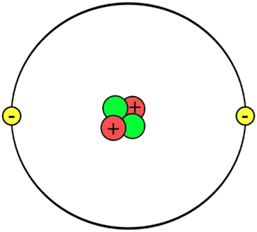

PART 2 – ISOTOPES
Video 2.1
Guided Notes
Complete the following as you watch the video.

Goal: This video explores the meaning of the word _________________ and what it has to do with the __________________________ inside of an atom.

What subatomic particle determines the type of element an atom will be?

Key Idea 1:

Describe why the atoms shown below are isotopes of one another.
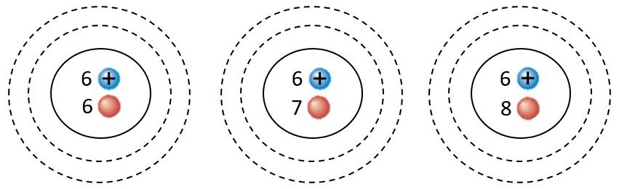

Do electrons effect whether atoms are isotopes of one another? Why or why not?

Key Idea 2:

Sample Discussion Questions
Consider how you would respond to the following questions. They will help prepare you for work and discussions that will take place in class after watching the video.

- Which of the atoms shown below are isotopes of one another? How do you know?
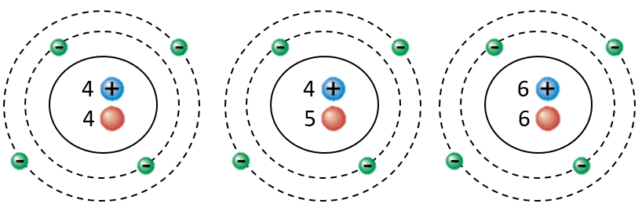

PART 3 – ATOMIC SYMBOLS
Video 2.2 and 2.3
Guided Notes
Complete the following as you watch the video.

Goal: This video covers the different types of ___________________ and __________________ used by chemists to describe an atom’s identity, mass, and charge.

Key Idea 1:

Key Idea 2:

Symbol 1: Isotopic Notation

Label what the variables X, A, and Z stand for in this notation style:

Example: Write the correct isotopic notation for the fluorine atom shown below.
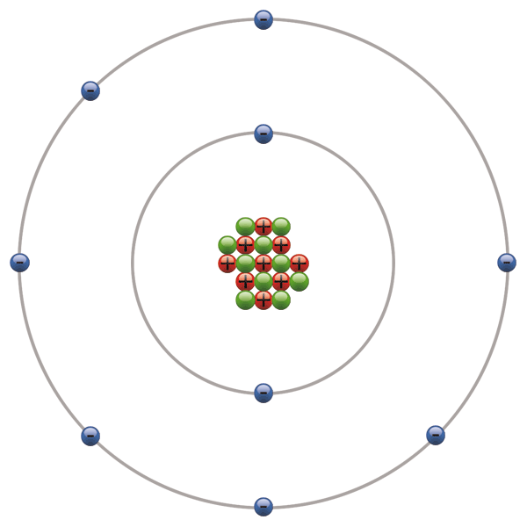

Example: How many subatomic particles are in an atom as described by the following isotopic notation?

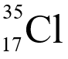
p⁺ = nº = e⁻ =

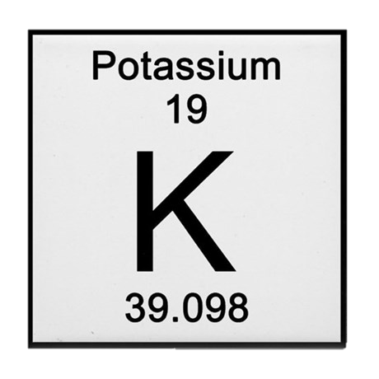
Symbol 2: Periodic Table Symbols

Label the information shown on each periodic table symbol:

PART 3 – ATOMIC SYMBOLS (continued)

In what two ways are periodic table symbols different from the isotopic notation?

1.

2.

Key Idea 3:

Symbol 3: Hyphen Notation

Key Idea 4:

Why is it okay to leave out the atomic number from the hyphen notation?
Use the chlorine example as a reference if needed.

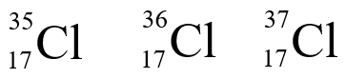
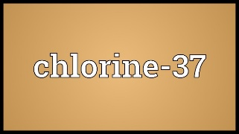

Sample Discussion Questions
Consider how you would respond to the following questions. They will help prepare you for work and discussions that will take place in class after watching the video.

- How many protons, neutrons and electrons are in an atom described by the following isotopic notation?

  - How would this symbol be different if it were on the periodic table? (2 ways)
  - Write the hyphen notation for the atom described by this isotopic notation.

PART 4 – CHARGES AND IONS
Video 2.4
Guided Notes
Complete the following as you watch the video.

Goal: This video takes a look at the factors that determine an _______________________________ and how to _______________________________________________________________________________.

What is an ion?

Key Idea 1:

Determining the Exact Charge:

Which hockey team is winning and by how much?
Are the protons or electrons winning and by how much?

What is the charge of an atom with the “score” of protons vs. electrons shown?

Which hockey team is winning and by how much?
Are the protons or electrons winning and by how much?

What is the charge of an atom with the “score” of protons vs. electrons shown?

Determine the charge of the atom shown by “keeping score” between protons and electrons.
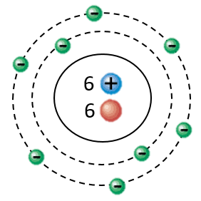

PART 4 – CHARGES AND IONS (continued)

Representing Charge in Symbols:

How is charge incorporated into isotopic notation?

Key Idea 2:

Key Idea 3:

Example: How many protons and electrons would be in an atom described by the two isotopic notations below?
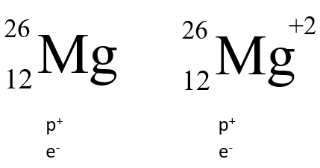

Sample Discussion Questions
Consider how you would respond to the following questions. They will help prepare you for work and discussions that will take place in class after watching the video.

- Which two subatomic particles will determine the charge of an atom?

- How many protons and electrons are in an atom described by the isotopic notation shown below?
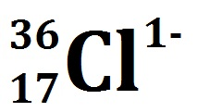

- How many protons and electrons are in an atom described by

PART 5 – SAMPLE QUESTIONS
Video 2.5
Guided Notes
Complete the following as you watch the video.

Goal: This video answers sample questions about ________________________________________________ that represent them.
Key Idea 1:
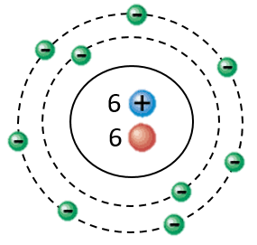

Example: Write the complete isotopic notation describing the atom shown.

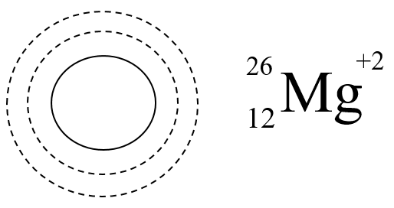

Example: Draw an atomic model as described by the isotopic notation given.

Example: Determine how many protons, neutrons, and electrons are in each of the following atoms.
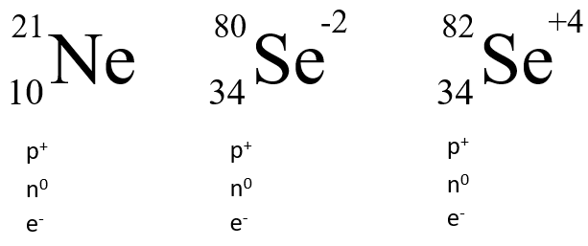

Sample Discussion Questions
Consider how you would respond to the following questions. They will help prepare you for work and discussions that will take place in class after watching the video.

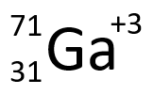
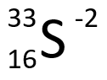
- How many protons, neutrons and electron would be in an atom described by each of the following isotopic notations?

PART 6 - CALCULATING AVERAGE ATOMIC MASS
VIDEO 2.6
Guided Notes
Complete the following as you watch the video.

Goal: This video shows you how to calculate the ________________________________________ of an element given _________________________________ and ___________________________________ data.

Why are many atomic mass values reported as decimals on the periodic table?

Key Idea 1:

Which Carbon isotope is most abundant? Write its complete isotopic notation.

Key Idea 2:

Example 1: Copper has two common isotopes: Cu-63 and Cu-65. Cu-63 has a percent abundance 69.09% and Cu-65 has a percent abundance of 30.91%. Calculate the average atomic mass.

Example 2: Magnesium has three naturally occurring isotopes. The percent abundances of these isotopes are as follows: Mg-24 (78.70%), Mg-25 (10.13%), and Mg-26 (11.7%). Calculate the average atomic mass of magnesium.

Sample Discussion Questions
Consider how you would respond to the following questions. They will help prepare you for work and discussions that will take place in class after watching the video.

- Calculate the average atomic mass of Carbon. It has three common isotopes: Carbon-12, Carbon-13 and Carbon-14, with percent abundances of 98.1%, 1.7%, and 0.2% respectively.

PART 7 – NUCLEAR STABILITY
VIDEO 2.7
Guided Notes
Complete the following as you watch the video.

Goal: This video shows you how to tell if an atom will be _________________________________________ by examining the _____________________________________ in the nucleus.

Key Idea 1:

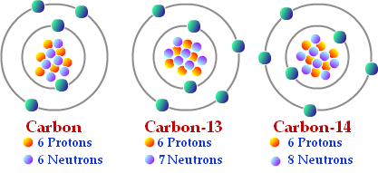
Label the carbon isotopes as stable or unstable. Which subatomic particles are effecting this?

What happens to stable nuclei?

What happens to unstable nuclei?

Key Idea 2:

Key Idea 3:

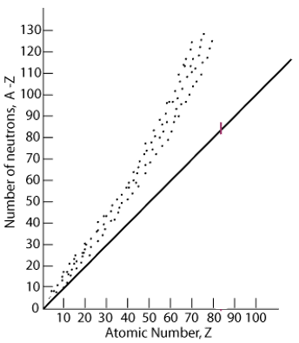
What do the “dots” represent on the graph?

What does the straight line represent?

Circle and label the region known as the “band of stability”?

Key Idea 4:

How can you tell if a nucleus is going to be stable?

Would an atom of Mercury, Hg, be stable or unstable if it had 90 neutrons?

PART 7 – NUCLEAR STABILITY (continued)
VIDEO 2.7

Sample Discussion Questions
Consider how you would respond to the following questions. They will help prepare you for work and discussions that will take place in class after watching the video.

- For a small atom like Beryllium with only 4 protons, about how many neutrons would likely be required to make the nucleus stable?

- Would an atom of Neodymium, Nd, be stable if it had 60 protons? How do you know?

- About how many neutrons would be required to make a stable Tin, Sn, atom?

- Write the complete isotopic notation for an atom of Lead, Pb, that is likely to be stable.

PART 8 – RADIATION TYPES
VIDEO 2.8
Guided Notes
Complete the following as you watch the video.

Goal: This video talks about the different types of ___________________ that can be emitted by _______________________________.

Key Idea 1:
(a repeat from the previous video)

What do unstable nuclei do when they decay?

What is radiation?

Since unstable atoms emit radiation, they are referred to as ___________________________.

Key Idea 2:

What are 3 types of ionizing radiation covered in this video?

Before radiation hits: After radiation hits:
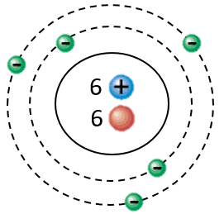
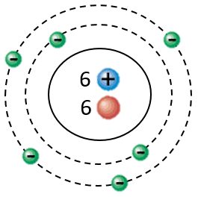

p⁺ = p⁺ =

n⁰ = n⁰ =

What does ionizing radiation do to an atom that turns it into an ion? Reference the diagrams above after filling in the proton and neutron count for each diagram.

 | What is it? | Composition | Isotopic Notation | Symbol
Alpha Particles
Beta Particles
Gamma Rays

PART 8 – RADIATION TYPES (continued)
VIDEO 2.8

Sample Discussion Questions
Consider how you would respond to the following questions. They will help prepare you for work and discussions that will take place in class after watching the video.

- Uranium-235 atoms are known to emit dangerous ionizing radiation. This radiation can damage the DNA inside of living animal cells, causing cancer and other radiation-induced illnesses.

- How many protons and neutrons do Uranium-235 atoms have?

- What particles could the Uranium-235 nuclei be emitting?

- Explain what the emitted radiation could due to the atom shown below that causes it to become an ion.
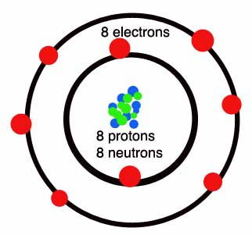

- What is the heaviest type of ionizing radiation?

- What types of ionizing radiation have no mass?

- Why do alpha particles have a +2 charge? Explain in terms of amounts of protons and electrons.

PART 9 – TRANSMUTATION EQUATIONS
VIDEO 2.9 AND 2.10

Guided Notes
Complete the following as you watch the video.

Goal: This video talks about how to write ___________________________________ that describe how unstable nuclei decay.

Key Idea 1:
(Isotopic notations of radiation types)
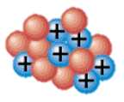

How does this nucleus change during an alpha decay?

Write the equation that describes this change:

Before After

Key Idea 2:

Example 1: Write the equation for the alpha decay of Nickel-60.

Example 2: Write the equation for the beta decay of Potassium-40.

Example 3: Write the equation for the alpha decay of arsenic-80.

Example 4: Write the equation for the beta decay of Cobalt-60.

PART 9 – TRANSMUTATION EQUATIONS (continued)
VIDEO 2.9 AND 2.10

Sample Discussion Questions
Consider how you would respond to the following questions. They will help prepare you for work and discussions that will take place in class after watching the video.

- Write equations for the alpha decay of the following isotopes:

- Nitrogen-16

- Lead-210

- Write equations for the beta decay of the following isotopes:

- Beryllium-10

- Gold-202

PART 10 – HALF-LIFE CONCEPT
VIDEO 2.11
Guided Notes
Complete the following as you watch the video.

Goal: This video talks about __________________________________________ different unstable nuclei to decay using the idea of a _____________________________.

Write the equation for the beta decay of Potassium-42:

The half-life of Potassium-42 is ________________________

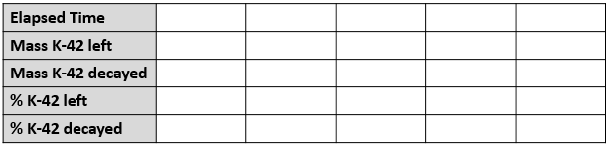

Key Idea 1:

Do all elements have similar half-lives? Give two examples.

Sample Discussion Questions
Consider how you would respond to the following questions. They will help prepare you for work and discussions that will take place in class after watching the video.

- If an element has a very short half-life, will it decay quickly or slowly?

- If an element has a long half-life, will it decay quickly or slowly?

- If a radioactive sample of Plutonium-230 has an initial mass of 100 grams, how much Plutonium will be left after 2 half-lives have passed?

PART 11 – HALF-LIFE EXAMPLES
VIDEO 2.12
Guided Notes
Complete the following as you watch the video.

Goal: This video takes a look at some sample questions that require the use of the _____________________.

Example 1: Nitrogen-13 emits beta radiation with half-life of 10 minutes. If you began with a 2.00 gram sample of N-13, how many grams would remain after 3 half-lives had passed? How long would this take?

Example 2: Manganese-56 is a beta emitter with a half life of 2.6 hours. What is the mass of Mn-56 in a 1.0-mg sample at the end of 10.4 hours?

Example 3: The mass of Cobalt-60 in a sample is found to have decreased from 0.800 g to 0.200 g in a period of 10.5 years. What is the half-life of Cobalt-60?

Sample Discussion Questions
Consider how you would respond to the following questions. They will help prepare you for work and discussions that will take place in class after watching the video.

- Radon-220 has a half-life of 1 minute. If you had an initial mass of 53 grams of Radon-220, how long would it take until only 6.63 grams of Radon-220 remains?

