Name: _________
Unit 1: Safety and Equipment
Test Review KEY

ROOM 406 VERSION

Part 1:
Label the locations of the following on the map shown below.
- Safety shower
- Eye wash
- Emergency gas shutoff
- Goggle cabinet
- Fire extinguisher

ROOM 404 VERSION

Part 1:
Label the locations of the following on the map shown below.
- Safety shower
- Eye wash
- Emergency gas shutoff
- Goggle cabinet
- Fire extinguisher

Part 2:
Circle TRUE OR FALSE for each statement below. If FALSE,
explain what is wrong with the statement.

1. Food and drinks are allowed in the classroom, but
are not permitted on the lab benches.

TRUE OR FALSE

Food and drink are never allowed in the classroom
2. Dangerous chemicals are illegal in a high school science lab, so any used solutions can be poured down the sink.

TRUE OR FALSE

We do use some dangerous chemicals, so always check disposal guidelines before putting down sink.

3. Goggles must be worn anytime glassware, chemicals or heat is being used in the chemistry lab.

TRUE OR FALSE

4. Sandals and flip flops are an acceptable form of footwear while in a chemistry lab.

TRUE OR FALSE

Sandals and flip flops do not protect your feet from spills and glass, so can not be worn in lab.

5. Long hair must be tied back at all times in a chemistry lab.

TRUE OR FALSE

6. When working with chemicals, minor cuts do not have to be reported to the teacher.

TRUE OR FALSE

Even minor cuts can introduce chemicals to your body, so always report all accidents to the teacher.

7. If a chemical splashes in your eye, immediately flush with water for 5 minutes.

TRUE OR FALSE

Flush with water for 20 minutes

8. In a chemistry lab, all chemicals are to be considered hazardous, so never drink, eat or smell them.

TRUE OR FALSE

9. If a large quantity of hazardous chemical spills on you and begins to burn, get the teachers attention immediately.

TRUE OR FALSE

Go straight to the safety shower without teacher approval. The quicker you act, the better!

Part 3:
Complete each of the following multi-part questions.

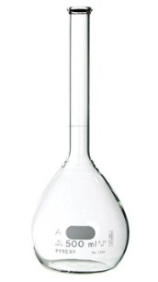
1. Refer to the pictures below when answering a – e.
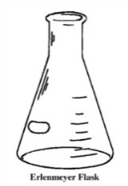
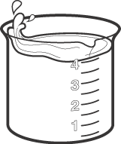

a. Which of the pieces of glassware above is an Erlenmeyer flask? The middle flask

b. Which of the pieces of glassware above would be most useful if you had to add one chemical to another while swirling vigorously. Erlenmeyer flasks are great for swirling without spills

c. Which of the pieces of glassware above would be most useful if you needed to create a solution with an exact volume. Volumetric flasks (the one on the far right)

d. Which of the pieces of glassware above is called a beaker. Far left container

e. If an empty volumetric flask (pictured above) tipped over and broke, what steps should be followed?
1. Alert the teacher
2. Clean up with dust pan (not bare hands)
3. Put in broken glass bin, not regular trash

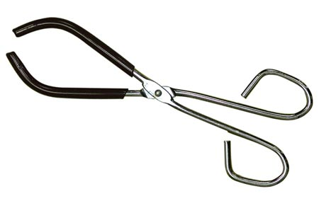
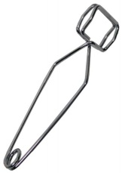
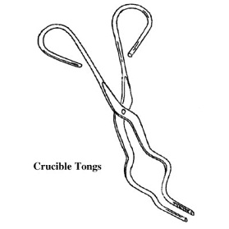
2. Refer to the pictures below when answering a – d.

a. Which tool is best suited for carrying a test tube that is too hot touch? Middle tool. This is a test tube holder and designed for carrying test tubes.

b. Which tool is a beaker tong? Far right

c. Which tool is best suited for carrying a crucible and cover that just came off of the Bunsen burner?
The tool on the far left is a crucible tong and made for moving crucibles

3. What is the name of the piece of laboratory equipment shown below?

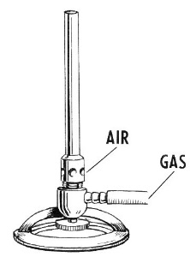
a. Name: Bunsen burner

b. What safety precautions must be taken when using this item?

- Be extra aware of your surroundings and movements so you don’t brush past the flame
- Tie back long hair, no loose clothing or jewelry
- Be aware that objects remain hot for a long time, so use tongs or hot hands when moving objects that have been heated here

c. What is another tool that could be used that would produce less heat, but in a more controlled fashion? Hot plate

