Get There:
Search for “phet Build an Atom” on Google or follow this link: https://phet.colorado.edu/en/simulation/build-an-atom
Click play to begin the simulation
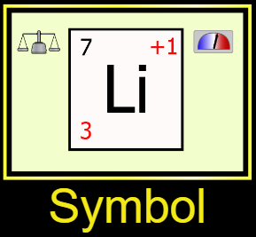
Begin by clicking on the “Symbol” section of the simulation.

Part 1: Isotopic Notation

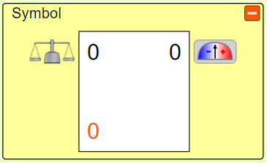
- The white box in the Symbol section of the simulation shows the symbol we use to describe an atom, sometimes called the isotopic notation.

- Build an atom with 2 protons, 2 neutrons and 2 electrons. Write the isotopic notation for this atom in the space below.

- The red number on the bottom left of the element symbol is called the atomic number. Add protons, neutrons and electrons to your atom and see which subatomic particles change the atomic number. Complete the statement below:

The atomic number indicates how many __________________ an atom has.

- The black number on the top left of the element symbol is called the atomic mass or mass number. Add protons, neutrons and electrons to your atom and see which subatomic particles change the atomic mass. Complete the statement below:

The atomic mass indicates how many ___________________ and __________________ an atom has.

- The atomic mass can also be expressed mathematically. Complete the equation below:

( the # of ________________ ) + ( the # of ________________ ) = the atomic mass

- This equation can be rearranged to help you solve for the number of neutrons an atom has.

the # of neutrons = ( the atomic mass ) - ( ____________________ )

- What is the atomic number of an atom with 5 protons and 6 neutrons? Use the simulation if needed.

- What is the atomic mass of an atom with 7 protons and 9 neutrons? Use the simulation if needed.

- What is the atomic number of an atom with 8 protons, 8 neutrons and 9 electrons? Use the simulation if needed.

- What is the atomic mass of an atom with 11 protons, 12 neutrons and 12 electrons?

- What is the atomic mass of an atom with 60 neutrons, 50 protons and 50 electrons?

- How many protons would an atom have with an atomic number of 9 and an atomic mass of 18? Use the simulation if needed.

- How many neutrons would an atom have with an atomic number of 4 and an atomic mass of 8? Show your calculation below even if you can do this in your head!

- How many neutrons would an atom have with an atomic number of 12 and an atomic mass of 26? Show your calculation below even if you can do this in your head!

- How many neutrons would an atom have with an atomic mass of 178 and an atomic number of 72. Show your calculation below even if you can do this in your head!

- Write the complete isotopic notation for the following atoms. Use the simulation to look up the element symbol if needed. You do not need to include the charge number in the upper right hand corner.

  - 4 protons and 5 neutrons

  - 10 protons and 12 neutrons

  - Atomic number of 6 and 6 neutrons

  - A gold atom (Au) with 79 protons and atomic mass of 190

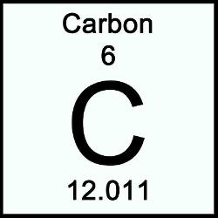
Part 2: Using the Periodic Table

The periodic table lists the atomic number and atomic mass differently than the isotopic notation does. On the periodic table, the atomic number is on top.

You might also notice that the atomic mass is a decimal. Don’t worry about that for now.

- Use a periodic table to look up the atomic number of phosphorus. Write the isotopic notation for an atom of phosphorus with 16 neutrons and 15 electrons.

- Use a periodic table to look up the atomic number of nickel. Write the isotopic notation for an atom of nickel with 32 neutrons and 28 electrons.

- Use a periodic table to look up the atomic number of barium. Write the isotopic notation for an atom of barium with 70 neutrons and 54 electrons.

Part 3: Non-Neutral Atoms (Atoms with a Charge) – only use this page if done on day 4 instead of day 3

- Build an atom that meets each qualification given below. Then answer any questions concerning that atom.
  - Boron atom with a -2 charge.
    - How many protons, neutrons and electrons does that atom have?

    - Did you need to adjust all three subatomic particles to create the atom as described? Explain.

  - Nitrogen atom with a mass of 15 and a -3 charge.
    - How many protons, neutrons and electrons does that atom have?

    - Did you need to adjust all three subatomic particles to create the atom as described? Explain.

  - Beryllium-5 and a +2 charge.
    - How many protons, neutrons and electrons does that atom have?

    - Did you need to adjust all three subatomic particles to create the atom as described? Explain.

  - Hydrogen atom with a + charge.
    - How many protons, neutrons and electrons does that atom have?

    - Did you need to adjust all three subatomic particles to create the atom as described? Explain.

- Using the simulation, a student is given the task of building a Fluorine-19 atom with a -1 charge. First, the student creates a neutral atom of Fluorine-19. Then, to give it a -1 charge, the student removes a proton so that there will be one more electron than protons. This does give the atom a -1 charge, but doesn’t completely achieve the original task. What did this student do wrong? Explain.
Hint: Use the simulation to mimic what this student did if you need help.

