**Percentages**

**% composition**= mass of element * 100%   
 mass of compound

**% error** = |experimental (measured) - accepted value| * 100%   
 accepted value

**% yield** = actual yield * 100%   
 theoretical (expected) yield

**Constants**

**Electron rest mass** 9.109 x 10-31 kg

**Neutron rest mass** 1.675 x 10-27 kg

**Proton rest mass** 1.673 x 10-27 kg

**Speed of light** (c)3.00 x 108 m/s

**Planck’s constant** (h)6.63 x 10-34 J*s

**Avogadro’s number** (NA) 6.022 x 1023 rep. part./1 mole

**Ideal Gas constant** (R) 8.314 L*kPa/mol*K

0.0821 L*atm/mol*K

**Ideal Gas molar volume** 22.4 L/1 mol

**Standard Temperature & Pressure (STP)** 0° C & 1 atm

**Chemical Bonding**

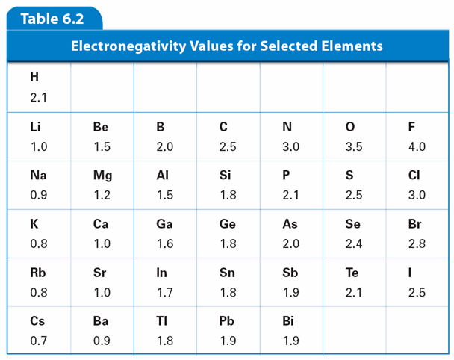

**Molecular Geometry**

|  |  |  |  |
| --- | --- | --- | --- |
| *Domain* | *Electron Pair Geometry* | *General Formula* | *Molecular Geometry* |
| 1 | linear | AX or A2 | linear |
| 2 | linear | AX2 | linear |
| 3 | trigonal planar | AX3 | trigonal planar |
| AX2E | bent |
| 4 | tetrahedral | AX4 | tetrahedral |
| AX3E | trigonal pyramidal |
| AX2E2 | bent |
| 5 | trigonal bypyramidal | AX5 | trigonal bypyramidal |
| AX4E | seesaw |
| AX3E2 | T-shaped |
| AX2E2 | linear |
| 6 | octahedral | AX6 | octahedral |
| AX5E | square pyramidal |
| AX4E2 | square planar |
| AX3E3 | T-shaped |
| AX2E4 | linear |

(A) central atom (X) attached atoms (E) lone pair electrons

**Heat of fusion of water** 6.01 kJ/mol

**Heat of vaporization of water** 40.7 kJ/mol

**Absolute zero**  -273.15° C = 0 K

**Specific heat of water** (c) 4.184 J/g*°C, 1 cal/g*°C

**Density of water** 1.00 g/cm3

**Kf water** 1.86 °C/*m*

**Kb water** 0.512 °C/*m*

**Kw water** 1 x 10-14

**Measurements**

**Temperature:** K = °C + 273.15

°F = 9/5 (°C) + 32

**Mass:** 1 kg = 1000 g

**Volume:** 1 Liter = 1000 mL = 1000 cm3

**Length:** 1 inch = 2.54 cm

**Energy:** 1 kJ = 1000 Joules = 239.01 calories

**Pressure:** 14.7 psi = 30 in Hg = 1 atm = 101.3 kPa = 760 torr = 760 mmHg

**Metrics:** 1 m = 102 cm = 103 mm = 106 μm = 109 nm = 1012 pm

1 kL = 1m3

|  |  |  |
| --- | --- | --- |
| kilo, hecta, deka | **basic unit**  (meter, Liter, gram) | deci, cent, meter |

**Nuclear Chemistry**

Alpha (α ) ${}_{2}^{4}{He}$ Beta (β) ${}_{-1}^{0}e$

Positron (β+) Gamma (γ) ${}_{0}^{0}{}$

Proton (*p*) ${}_{1}^{1}p$ Neutron (*n*) ${}_{0}^{1}n$

Half-life $A=A_{0}{(\frac{1}{2})}^{n}$

**Electrons in Atoms**

$c=λν$ $Ε=hν$ $Ε=\frac{hc}{λ}$

**States of Matter**

Density $D=\frac{m}{V}$

Combined Gas Law 

Dalton’s law of partial pressures 

**Chemical Equilibrium**

General expression for Keq equation

aA + bB ⇔ cC + dD

Keq = [C]c[D]d Ksp= [C]c[D]d

[A]a[B]b

Ideal Gas Law 

Graham’s Law $\frac{{rate}_{1}}{{rate}_{2}}=\frac{\sqrt{M_{2}}}{\sqrt{M_{1}}}$

**Honors Chemistry 2018-2019 Equation Sheet**

**Polyatomic ions**

acetate C2H3O2 1- hydroxide OH1-

ammonium NH4 1+ hypochlorite ClO1-

carbonate CO3 2- nitrate NO3 1-

chlorate ClO2 1- nitrite NO2 1-

chlorite ClO3 1- oxalate C2O4 2-

chromate CrO4 2- perchlorate ClO4 1-

cyanide CN1- permanganate MnO4 1-dichromate Cr2O7 2- peroxide O 2-

dihydrogen phosphate H2PO4 1- phosphate PO4 3-

hydrogen carbonate (bicarbonate) HCO3 1- phosphite PO3 3-

hydrogen phosphate HPO4 2- silicate SiO3 2-

hydrogen sulfate HSO4 1- thiocyanate SCN1-hydrogen sulfite HSO3 1- sulfate SO4 2-

sulfite SO3 2-

**Organic Chemistry**

|  |  |  |
| --- | --- | --- |
| **Type** | **General Structure** | **Name** |
| alkene |  | -ene |
| alkyne |  | -yne |
| halocarbon |  | fluoro-, chloro-, bromo-, iodo- |
| alcohol |  | -ol |
| ether |  | ether |
| amine |  | amine |
| aldehyde |  | -al |
| ketone |  | -one |
| carboxylic acid |  | -oic acid |
| ester |  | -oate |
| amide |  | amide |

**Chemical Reactions Activity Series of the Elements**

**General Solubility Guidelines**

**General Combustion Equation:**

**CxHy + (x + ()) O2 🡪 x CO2  + () H2O**

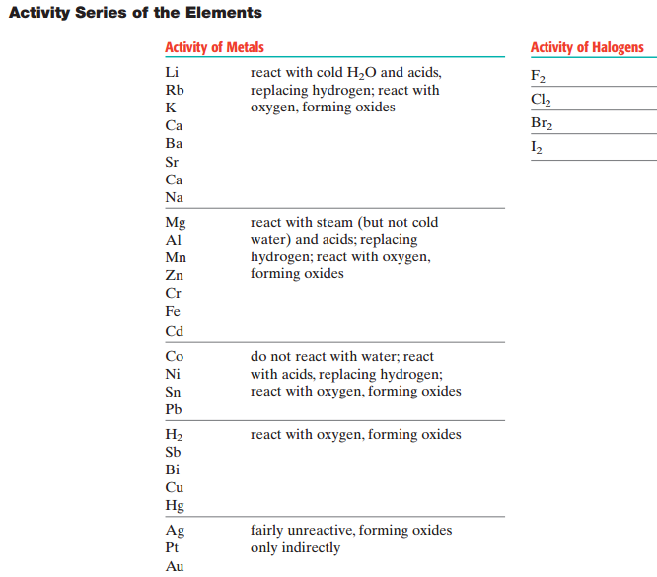

**Solutions, Acids and Bases**

(%(v/v) = volume of solute/volume of solution x 100%

(%(m/m) = mass of solute/mass of solution x 100%

Parts per million = (mass of solute/mass of solution) x 106

Parts per billion = (mass of solute/mass of solution) x 109

Molarity (M) = moles of solute/ L solution

Molality (*m*) = moles of solute/ kg solvent

Dilutions: M1V1 =M2V2

Henry’s Law

ΔTf = Kf *m* i ΔTb= Kb *m*  i

pH = -log [H3O+] pOH = -log [OH-]

Kw = [H+][OH-] = 1 x 10-14 pH + pOH = 14

$$K_{a}= \frac{\left[H^{+}\right][conjugate base]}{[acid]} K_{b}= \frac{\left[conjugate acid\right][{OH}^{-}]}{[base]}$$

Titrations: MAVA =MBVB

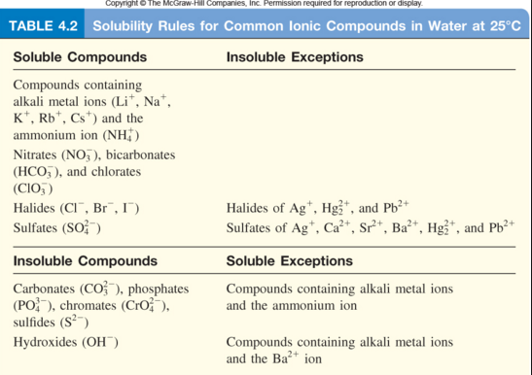

**Thermochemistry**

q = mcΔT

Enthalpy of a Reaction (H)

ΔHrxn° = ΔH°f (products) - ΔH°f (reactants)

Entropy of a Reaction (S)

ΔSrxn° = ΔS°f (products) - ΔS°f (reactants)

Gibb’s Free Energy (G)

ΔG = ΔH – TΔS