HONORS CHEMISTRY: UNCERTAINTY OF INSTRUMENT READINGS AND OTHER RAW DATA
- Data in the lab is measured by including all of the KNOWN digits plus one estimated digit. For example in the thermometer below, the gradations each represent 2°F. The measurement is “known” to the tens place. We need to include an “estimated” digit as well so the correct data measurement would be to the tenths place.
Correct Measurement: 76.0°F
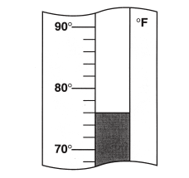
- Every measurement in the lab has uncertainty associated with it – this is written as:
MEASUREMENT ± UNCERTAINTY
There are three types of uncertainty:
- Absolute uncertainty – this is what we will use in lab this year. This is the actual uncertainty in a quantity relative to the instrument being used. In the thermometer example above, the last digit represents the estimated or “uncertain” digit. We always place a “1” in the uncertain place. The uncertainty would be ±0.1.
- Relative uncertainty – expresses the uncertainty as a fraction of the quantity of interest. The relative uncertainty is calculated as: absolute uncertainty / measured quantity
For the thermometer example, the relative uncertainty would be calculated as:
0.1 / 76.0 = 0.0013
- Percent uncertainty – relative uncertainty x 100
For the thermometer example, the percent uncertainty would be calculated as:
0.0013 * 100 = 0.13

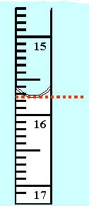
EXAMPLE #1: A student measures the volume of a burette below. Be sure to list the appropriate number of digits, as well as the absolute, relative, and percent uncertainty that goes along with the measurement.
Absolute: _____________________________
Relative:______________________________
Percent:_______________________________

EXAMPLE #2: Convert the following to relative uncertainties:
- 2.70± 0.05 cm b.) 12.02 ±0.08 cm

EXAMPLE #3: Convert the following to absolute uncertainty:
- 3.5 ± 10% cm b.) 16 ± 8% s

EXAMPLE #4: Use the following scales to measure the quantities required. Be sure to list the appropriate number of digits as well as the ABSOLUTE uncertainty that goes along with each measurement.

